🎀 Elevate your style with ***Adore Us with Scrunchies***! 🎀

Our newest line of scrunchies adds the ideal splash of color and flair to any outfit. Discover your next best item right now, choosing from eye-catching patterns to timeless neutrals! 🌼 Shop now to change the way you look quickly!

#ScrunchieStyle #Accessorize #HairGoals #FashionAccessories #accessorize"

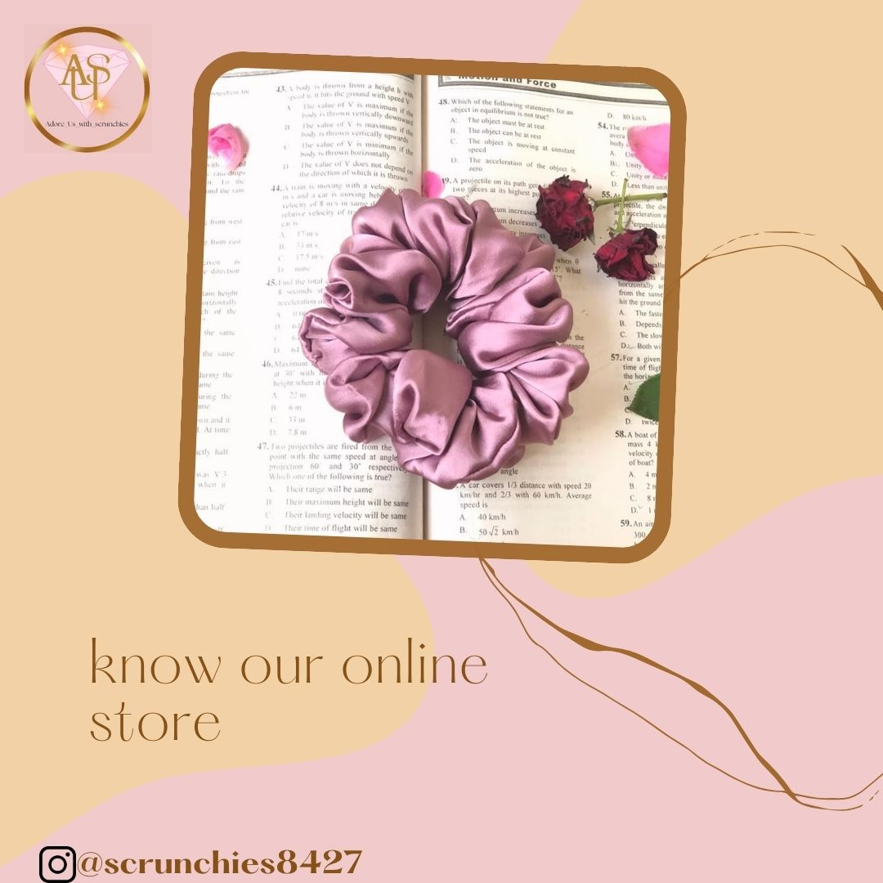

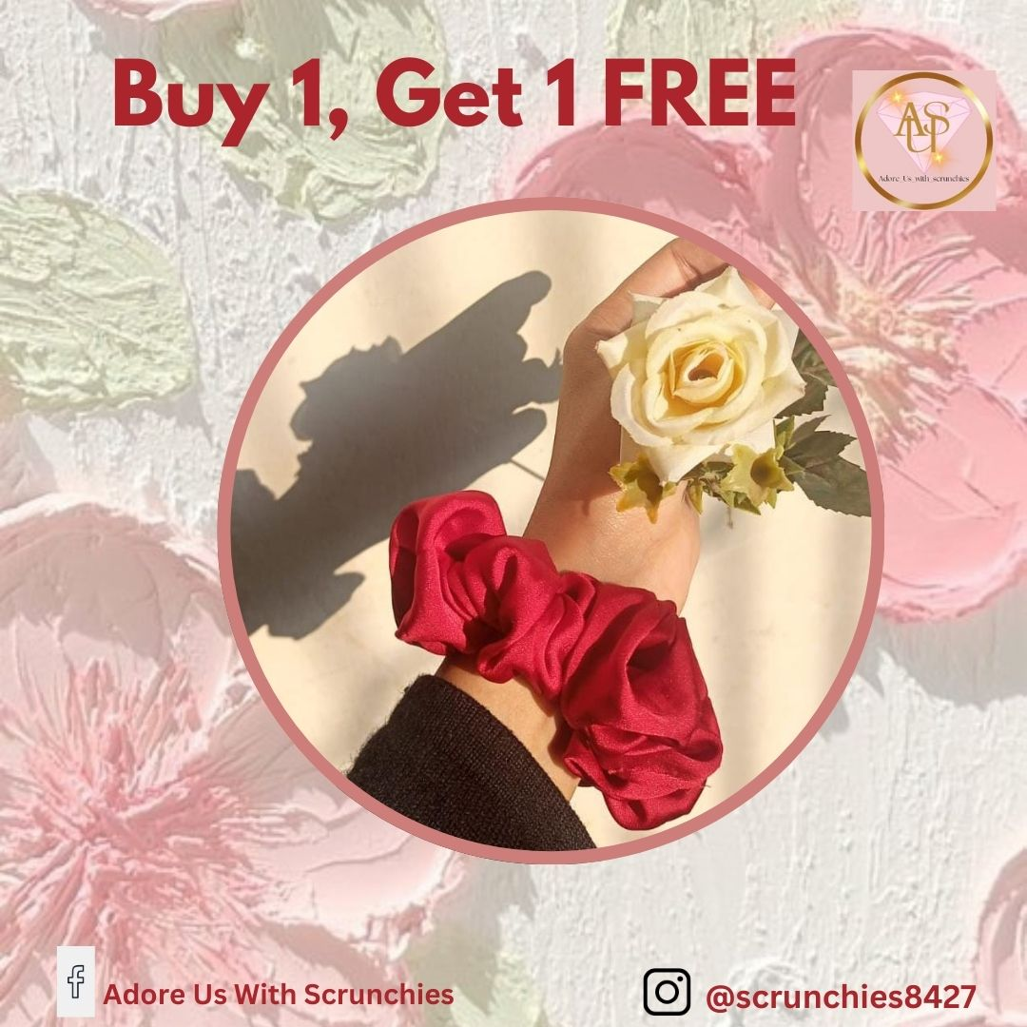

**Hashtags:**

#AdoreUswithScrunchies

#FashionAccessories

#HairGoals

#ScrunchieStyle

#Accessorize

**Mentions:**

Tag related brands or influencers to grab their audience, increase visibility, and cross-promotion.

**Scheduling:**

Post Time: Between 10 AM and 2 PM in the late morning or early afternoon to capture the audience during their breaks.

**Engagement:**

Once Published: In response to inquiries such as "Which scrunchie is your favorite?" provide specifics regarding various designs or fashion advice. Interact with users who ask inquiries about the products or share their scrunchie styles.